# Annual Pack 511 Planning Meeting

# 2023 – 2024 Program Year

**Planning Meeting Agenda & Objectives**

**Meeting Time:**

**Location:**

**Meeting Objectives**

* Design annual program calendar for 2023-2024 year
* Review Leadership Team; Development and Training Goals
* Review Den Approach / Rotations for Pack events & meetings
* Review and Approve Camp Out schedule
* Review Fundraising Activities
* Review approach to Roundup & Tigers
* Review new BSA Program Changes

**Pre- Meeting**

* Review BSA Training Printout to make sure you have the requisite training (position specific, YPT, etc.)
* New Leaders Applications – Turn in at planning Meeting
* Youth Protection Training – Review Training
* ALL SCOUTS ADVANCED IN SCOUTBOOK
* Den leaders who were handed Guidebook last year, please return for new leader.

**Introduction**

The planning guide’s purpose is threefold;

* First, it documents the Pack program plan for the year so that all leaders understand who is performing which roles, what events will happen, and what other special activities will happen.
* Second, the document serves as a tool to evaluate how well the plan was executed and provides mechanism for assessing lessons learned.
* Third, it is a place for the pack to set goals, document guiding principles, and record important “whys.” Why are we changing something? Why didn’t that work last year? Perhaps most important, “Why are we scouting?”

**Pack Mission & Goals**

**Vision**

Cub Scouts is having FUN while teaching young boys and girls how to make good choices, learn about the outdoors, be good citizens, … So our Leaders having FUN, lead to families having FUN, lead to scouts having FUN, lead to boys and girls becoming men and women of character. So let’s always have FUN!

**Mission**

Pack 511 gets outside, shows scout and community spirit, engages the whole family, grows cub scouts into SCOUTS BSA scouts, and develops our scout’s self-confidence… all while having FUN

**Goals**

| **Summary Goals** | |
| --- | --- |
| Increase Recruitment  Achieve JTE Gold  **Increase Parent Involvement**  YPT for all parents?  New Activities for Pack  Virtual Meeting / Den Meetings  Pack Meeting Locations and Times | Rank Completion – ALL SCOUTS  Sync Den Meetings to Pack Meeting   * Regular Meetings * Keeping Scouts Engaged   Broaden Leadership and ownership within the Pack to all parents |

AGENDA

**Year in Review**

* Monthly Pack Meetings
* Den Meetings
* Virtual Commitee meetings

**Pack Roles**

* BALOO Training!
* Open Leader positions – Lion Den Leader, Tiger Den Leader?

**Calendar**

* Camping Opportunities – Outside District offerings
* Destination Sites / Blue & Gold
* 1 Event per Month
* Den Meetings Match Pack Meeting Themes

**Hike Club**

**Service Projects**

**Religious Emblems**

**Leader Awards**

**Financials**

* Dues and New Registration Costs
* Popcorn and outside fund raising opportunities
* Raffle Prizes (uniform Inspections) / Equipment Locker

**Recruitment**

* Open House & Round-up (collect tubs AEAP from Alex)
* Back to Pack
* 1st meeting of the year in Sept – DATE
* Parent Orientation

**Communications**

* Materials distributions to Parents
* Recruitment

**Meeting Locations**

* Virtual, Homes, Club House, Parks
* Den Leader Led Pack meeting
* Strengthen Parent involvement
* Practice Ceremonies/Pack Mtg Behavior

**YEAR IN REVIEW**

**Lesson Learned from 2022 – 2023**

| **Item** | **Comments/Considerations** |
| --- | --- |
| Roundup | * Prior year Roundup generated ________sign-ups * Leaders should be present! |
| Recruitment Activities | * Back to pack last year - Scout day wear your shirt recruitment - or invites printed * Table at Open House/Curriculum Night * Open Invite to PWD races |
| Dens | * 2 Lions → * 6 Tigers → * Wolf → * Bears, → * Webelos and AOLs → |
| Camping | * 3 Pack Level trips   + FFC   + Yorktown   + Tellus Museum |
| Large Events | * PWD - |
| Blue & Gold | * B&G – held at RSUM - with magician |
| Other Activities | * HIKE CLUB – Successful Second Year   + Suwanee Greenway – Good   + Amicalola – Good – but a bit strenuous – Park was crowded   + Pack Hike – Indian Seats – Good   + Yonah – Good, participation, cold in the morning   + Ivy Mill Greenway – Good   + Mulberry – relatively low participation   + Several Scouts earned their staff’s this year (At B&G) |
| Crossover Pack Meeting | * New Bridge! |
| Pack Service Project | * Individual service project encouraged * Group Project: Jambos? |
| Leadership Training and Development | * YPT is now mandatory as soon as you register * Need BALOO TRANING for current leaders |

**NOTES:**

* **Parent Orientation night is being suggested by District leaders and from prior year’s notes. This can be combined into September’s Pack Meeting or a separate night.**
* **Back to Pack can be an open invitation for Scouts to invite a Friend from school or neighborhood**
* **PWD – Invite the firefighters to join the race as a Cheaters group and judges**
  + **Pack shot a video (thanks Claire!)**

**PACK ROLES**

Our goal is fill out the program year with a full complement of trained leaders, with the exception of incoming Lion/Tiger Dens when no siblings of a current scout family are present. The following section details our leadership rooster for the program year. Changes in individuals and training status will be made as needed.

**GOAL: All committee members should have at the minimum Position Specific Training and Youth Protection**:

*EMERITUS* Indicates out-going leader to be training Current leader and/or Current Leader

**Pack Roles – Committee & Cubmaster**

| **Role** | **Individual** | **Secondary** | **Emeritus** |
| --- | --- | --- | --- |
| Committee Chair | John Alford |  | John Alford |
| Treasurer | John Alford |  | John Alford |
| Advancement Chair | Claire Keyser |  | Claire Keyser |
| Fund Raising Chair | Makeda Minot | John Alford | Makeda Minot |
| Secretary |  |  |  |
| Communications / Web | Claire Keyser (Facebook) |  | Claire Keyser (Facebook) |
| Cubmaster | Scott Shearon |  | Scott Shearon |
| Assistant Cubmaster | Krystal Shearon |  | Krystal Shearon |
| Outings Chair | Cedric James | John Alford | Cedric James |
| Trainer (Cubmaster) | John Alford | Scott Shearon | John Alford |
| Ceremony Chair (Blue & Gold, Crossover, Bobcat) |  |  |  |
| Membership & Registration |  |  |  |
| Chartered Org Rep | Kathy Hawks |  | Kathy Hawks |

**Training Status:** Trained Leadership status is considered YPT and one Position Specific training

(DL = Den Leader, CC =Committee Chair, CM = Cubmaster) – Pack Must maintain at least 2 BALOO Leaders for best practices.

Depending on Budgetary constraints, Pack Committee may decide to reimburse Adult Leaders for further training opportunities

**NOTES:**

**ALL Leader YPT should be up to date through 2023. YPT is required to be RENEWED every 2 YEARS.**

**Position Specific training will be very helpful as we transition into new roles this year and going forward.**

**Pack Roles – Dens.** All den leaders should have Den Leader Specific Training and Youth Protection:

| **Den** | **Role** | **Individual** | **Training Status** |
| --- | --- | --- | --- |
| Lions | Lions Coordinator |  |  |
| Tiger | Tiger Den Leader |  |  |
| Tiger | Tiger Asst. Leader |  |  |
| Wolf | Wolf Den Leader | Krystal Shearon | Trained |
| Wolf | Wolf Assistant Leader |  |  |
| Bear | Bear Leader | Mike Benken |  |
| Bear | Bear Asst. Leader | Claire Keyser | Trained |
| Webelos I | Webelos Leader | John Alford | Trained |
| Webelos I | Webelos Asst. Leader |  |  |
| AOL | AOL Leader | Cedric James | Trained |
| AOL | AOL Asst. Leader |  |  |

**Trained: Refers to YPT completed and update to date (bi-yearly) and Position Specific training.**

* ***All leaders who have attended Youth Protection Training should submit copy of document to the pack.***
* ***All leaders who have attended a position specific training course should submit documentation to the pack.***

**NOTES:**

* [**https://my.scouting.org/dashboard-legacy**](https://my.scouting.org/dashboard-legacy) **- Online Training for all leaders is available at the weblink for MY.SCOUTING.ORG.**
* **Four (4) Baloo trained leaders exist in the Pack (Scott, Shearon, Claire Keyser, Krystal Shearon, and John Alford). New BALOO Trained leaders will be required.** 
  + **Training is available with several districts around us. Dates are in our calendar**
* **Girls in Scouting - In all girl’s den, one leader must be female. If den is both genders, then den must have a female leader**

**EVENTS CALENDAR**

**Schedule of Events**

Below is the schedule of key events, firm or tentative dates, and event chair. The following guidelines are provided to help establish and aid schedule decision-making.

**Schedule Guidelines**

* At least one pack event every month.
* No more than 2 pack level events in any given month
* No meetings during the week(s) of CRCT testing
* Minimize pack level activities during November and December due to school breaks
* Strive for a balanced year, avoid too many activities scheduled together
* Leave room for at least two den meetings per month for Dens
* **All Den and Pack Events should be documented in our system of record (SCOUTBOOK)**

**Pack Event Schedule (With Selected District Events) *Adult Training Opportunities**

| Month | Event (YELLOW IS UNCONFIRMED) | Date | Organizer / Chair |
| --- | --- | --- | --- |
| July | **Program Preview (Church on the Hill)**  **Annual Planning Meeting** | **7/20 - 7pm**  **7/28 – 7 PM** | **Krystal Shearon**  **ALL LEADERS** |
| August | **Round Up Orientation** **(Prospect UMC)**  First Day of School  **District Committee Training**   * **(Gainesville Baptist)**   **Wilderness First Aid - Scoutland**  Scout Night with the Atlanta United  Back to Pack | **8/1 - 7pm**  8/2  **8/12 - 8:30-12:30**  **8/19**  8/26 - 7:30 pm  TBD | **Krystal Shearon**  GCPS  **NEGA Council**  NEGA Council  NEGA Council  ALL LEADERS |
| September | **Leader Specific Training (RSUMC)**  **Pack Leaders Mtg. via Zoom**  Scout Night with the Stripers  Round Up (Rock Springs Elementary)  **BALOO - Scoutland**  **Leader Specific Training (RSUMC)**  Pack Meeting (RSUMC)  Webelos Woods  **BALOO - TBD**  **Leader Specific Training - TBD** | **9/2**  **9/7**  9/8 - 6pm  TBD  **9/15 - 9/17**  **9/23**  9/28 - 7pm  9/29 - 10/1  **9/30**  **9/30** | **John Alford**  NEGA Council  Pack 511  **NEGA Council**  **NEGA Council**  Pack 511  NEGA Council  **Cherokee District**  **Cherokee District** |
| October | **Pack Leaders Mtg. via Zoom**  Fall Break/Student Holiday  Tigermania (Church on the Hill)  Autumn Adventure/Fall Family Camping  **Tali Atsila (WK1) - Scoutland**  Pack Meeting (RSUMC)  **BALOO - Scoutland** | 10/5 - 7pm  10/5 - 10/9  10/7 - 8:30 - 1pm  10/13- 10/15  **10/14**  10/26  **10/27** | John Alford  NEGA Council  NEGA Council  **NEGA Council**  Pack 511  **NEGA Council** |
| November | **Pack Leaders Mtg. via Zoom**  Cub Scout Fun Day  **Wilderness First Aid**  Webelos Transition Faire  **Tali Atsila (WK2) - Scoutland**  Pack Meeting (RSUMC) | 11/2 – 7 PM  11/4 - 8:30-1pm  **11/4 - 11/5**  11/9 - 7pm  **11/10 - 11/12**  11/23 - 7pm | John Alford  Apalachee District  NEGA Council  Apalachee District  NEGA Council  Pack 511 |
| December | **University of Scouting/Leader Specific Training**  **Pack Leaders Mtg. via Zoom**  Service Project  Pack Meeting  Winter Break | **12/2**  12/7 – 7 PM  12/9  12/14 – 7 PM  12/18- 1/3 | NEGA Council  John Alford  Pack 511  Pack 511  Pack 511  GCPS |
| January | **Pack Leaders Mtg. via Zoom**  PWD Workshop  MLK Holiday  Scout Night with the Gladiators  Pack Meeting | 1/4 – 7 PM  1/7 – 9 AM  1/15  1/20  1/25 – 7 PM | Scott Shearon  John Alford  NEGA Council  Pack 511 |
| February | **Pack Leaders Mtg. via Zoom**  PWD Check-In  *Possible Okefenokee  School Break/Long Weekend  Scout Night with the Gladiators  Pack Meeting in person PWD!  Loop -A-Rama  * Possible Blue & Gold | 2/1 – 7 PM  2/10  2/15 - 2/19  2/15-19  2/16  2/22 – 7 PM  2/24 - 9 -1pm  2/24 | Scott Shearon  Pack 511  Pack 511  GCPS  NEGA Council  Pack 511  Apalachee District  Pack 511 |
| March | **Wilderness First Aid**  *Possible Blue & Gold  **Pack Leaders Mtg. via Zoom**  *Possible Okefenokee  Spring Fling  **Adult Awards Banquet**  Pack Meeting | 3/1 - 3/3  3/2  3/7 – 7 PM  3/15 - 3/17  3/15 - 3/17  3/23 - 6:30pm  3/28 – 7 PM | NEGA Council  Pack 511  Scott Shearon  Pack 511  NEGA Council  Apalachee District  Pack 511 |
| April | Spring Break  **Pack Leaders Mtg. via Zoom**  **Woodbadge (WK1)**  Scout Show  Pinewood Derby/**Outlaw Race**  Pack Meeting  Spring Family Camping - Rainey Mtn | 4/1-5  4/11 – 7 PM  4/19 - 4/20  4/20 - 9am-3pm  4/20  4/25 – 7 PM  4/26 - 4/28 | GCPS  Scott Shearon  NEGA Council  NEGA Council  NEGA Council  Pack 511  NEGA Council |
| May | **Pack Leaders Mtg. via Zoom**  **Woodbadge (WK2)**  Pack Meeting – Crossover/Graduation  Last Day of School | 5/2 - 7pm  5/4 - 5/5  5/16 – 7 PM  5/22 | Krystal Shearon  NEGA Council  Pack 511  GCPS |
| June | Summer Activity 1 – | 6/17 |  |
| July | Summer Activity 2 –  **Annual Planning Meeting** | 7/15  7/30 6-9pm | ALL LEADERS |

**EVENTS NOT YET SCHEDULED**

| **Service Projects (Sep)**  **Round Up (Aug)**  **Pack Hike (Nov)**  **Hike Club** |
| --- |

**Pack Leadership Meetings**

Below is the schedule for Pack Leadership meetings. Committee meetings are held regularly and cover planning for upcoming pack events. Committee meeting attendance includes those in committee roles or individuals leading an upcoming pack event. Den Leaders and parents are always encouraged to participate as schedule permits. From time to time, the Committee Chair may designate a meeting as “Leader All Hands” where full attendance by Den Leaders is requested.

**Pack Leadership Meeting Schedule (Need at Least Six for JTE)**

| Month | Event | Date |
| --- | --- | --- |
| July | Annual Planning Meeting | 7/28/23 |
| Aug |  |  |
| Sept | Committee Meeting | 9/7/23 |
| Oct | Committee Meeting | 10/5/23 |
| Nov | Committee Meeting | 11/2/23 |
| Dec | Committee Meeting | 12/7/23 |
| Jan | Committee Meeting | 1/4/24 |
| Feb | Committee Meeting | 2/1/24 |
| Mar | Committee Meeting | 3/7/24 |
| April | Committee Meeting | 4/11/24 |
| May | Committee Meeting | 5/2/24 |
| June |  |  |
| July | Annual Planning Meeting | 7/30/24 |

NOTES:

* Troop 511 have the Fellowship hall Every Tuesday (Bottom Level)
* Pack 511 has 4th Thursday – additional dates will need to be booked ad-hoc thru church

**3-month timetable to facilitate pro-active pack planning**

| **MTG Month** | **Date** | **Outline Month** | **Finalize Month** | **Communicate Month** |
| --- | --- | --- | --- | --- |
| July | 7/28/23 |  |  |  |
| Aug |  | Oct | Sept | Aug |
| Sept | 9/7/23 | Nov | Oct | Sept |
| Oct | 10/5/23 | Dec | Nov | Oct |
| Nov | 11/2/23 | Jan | Dec | Nov |
| Dec | 12/7/23 | Feb | Jan | Dec |
| Jan | 1/4/24 | Mar | Feb | Jan |
| Feb | 2/1/24 | April | Mar | Feb |
| Mar | 3/7/24 | May | April | Mar |
| April | 4/11/24 | June | May | April |
| May | 5/2/24 | July | June | May |
| June |  |  |  | June |
| July | 7/30/24 |  |  | July |

**NOTES:**

**LEADERSHIP MEETINGS ARE ZOOM UNTIL FURTHER NOTICE**

**Pack Meetings 2023/2024 – Pack Focus and Den Themes**

Below is the schedule for Pack Leadership

| Month | Meeting Date | Pack Meeting Focus | Pack Meeting Activity | Pack Monthly Theme | Ceremony Den  Opening/Closing |
| --- | --- | --- | --- | --- | --- |
| Aug | 8/26/23 | *Back to Pack* | Outdoor Scavenger Hunt  Leave no Trace |  |  |
| Sept | 9/28/23 | **Brave - Paws on the Path (Wolf)** | Outdoor Code 4C’s  Hiking Safety, Buddy System  6 Essentials  Appropriate Clothing | Exercise, Camping, , Outdoors | AOL |
| Oct | 10/26/23 | **Loyal -** |  | Teambuilding, Healthy Eating | Web I |
| Nov | 11/16/23 | **Trustworthy -** | **pack trip to zoo/wildlife refuge/nature center/aviary/conservation area**  **Meeting will be themed to follow up with the field trip** | Citizenship, Community Service | Bears 1 |
| Dec | 12/14/23 | **Reverent -** | Potluck | Faith & Diversity | Wolves |
| Jan | 1/25/24 | **Clean -** | first aid | Emergency Prep, First Aid, & Safety | Tigers/Lions |
| Feb | 2/29/24 | **Thrifty -** | PWD | Cool Gadgets | AOL |
| Mar | 3/28/24 | **Cheerful - Furs, Feathers, Ferns (Bear)** | -plant vegetable/herb garden  -examine plants closely with a magnifying glass  - composting/vegetable waste | Skits, Songs, & Stories | Web I |
| April | 4/25/24 | **Courteous - Into the Wild (Webelos)**  **Pack Conservation Project** | (optional nontraditional meeting) - start at Collins Hill Park near the softball stadium - 1-mile loop behind the aquatic center - trash clean up, water cycle craft (need idea), watershed importance testing pH and temperature, native birds of the area | Conservation | Bears 1 |
| May | 5/16/24 | **Helpful -** | CROSS OVER |  | Wolves |
| June | 6/15/24 |  |  |  |  |
| July | 7/13/24 |  |  |  |  |

**\*Please reference Appendix L for plan meeting ideas\***

**\*\* Please reference Appendix M for meeting materials\*\***

[**World Conservation Award**](https://www.scouting.org/wp-content/uploads/2022/07/512-03622-CS-World-Conservation-Award-App.pdf)

[**Scout Tracker**](https://docs.google.com/spreadsheets/d/1-8o_FI88loEFOAqRMEnQ27yn9kDb-lo_ve7Nh7wItSo/edit?usp=sharing)

| **Wolf** | **Bear** | **Webelos** |
| --- | --- | --- |
| * **Earn the Paws on the Path adventure. (Nov/February Den)** * **Select a seed, and plant it in a small container. Care for it for 30 days. Take a picture or make a drawing of your plant once a week to share with your den or family. (March Den)** * **Find out the growing zone for your area and share the types of plants that will grow best in your zone. (March PACK)** * **Visit or research a botanical or community garden in your area and learn about two of the plants that grow there. Share what you learned with your den or family. (April Den)** * **Make a terrarium. (January Den)** * **Complete requirements 1 and 2 from the Spirit of the Water adventure. (February Pack)** * **Participate in a den or pack conservation project in addition to the above.** | * **Earn the Fur, Feathers, and Ferns adventure. (Recommend Okefenokee)** * **Earn either the A Bear Goes Fishing or Critter Care adventure. (Den or Okefenokee Recommended)** * **Complete requirement 3 from the Baloo the Builder adventure by constructing a bird feeder or a bird house as one of the options. (Den Meeting)** * **Participate in a den or pack conservation project in addition to the above.** | * **Earn the Building a Better World adventure. (Covered?)** * **Earn the Into the Wild adventure. (Recommend Okefenokee or DEN Meeting)** * **Earn the Into the Woods adventure. (Recommend Okefenokee)** * **Earn the Earth Rocks adventure. (February/March Pack)** * **Outline a fair test that shows what you need to do to test a fertilizer’s effect on plant growth. (Den Meeting)** * **Carry out the experiment you designed in requirement 5.** * **Carry out the experiment again but change the independent variable. Report what you learned about how changing the variable affected plant growth.** * **Participate in a den or pack conservation project in addition to the above.** |

**Theme Matrix**

| **Theme** | **LION** | **TIGER** | **WOLF** | **BEAR** | **WEBELOS** | **AOL** |
| --- | --- | --- | --- | --- | --- | --- |
| **Hiking** | **Mountain Lion**  I’ll Do It Myself | **Tigers in the Wild** | **Paws on the Path** | **Fur Feathers and Friends** | **Webelos Walkabout** | Into the Wild |
| **Team Building, Healthy Eating** | **Fun on the Run** | **Bobcat Rank**  Good knights | **Running with the Pack,**  Paws of Skill | Bear Picnic Basket | **Cast Iron Chef** | Castaway |
| **Exercise, Camping, Outdoors** | **Lion’s Honor,** On Your Mark | **Games Tiger’s Play**  Sky is the Limit | **Call of the Wild,** | **Bear Necessities /** Super Science | **Stronger, Faster, Higher** | **Outdoor Adventurer** |
| **Citizenship, Community Service** | **King of the Jungle**, Gizmos and Gadgets | **Team Tiger, Tiger Bites** | **Council Fire (Duty to Country)**  Adventures in Coins | **Paws For Action (Duty to Country)**  Forensics | Aware and Care | **Building A Better World** |
| **Faith & Diversity** | Pick My Path | **Tiger Circles**  **(Duty to God)**  Rolling Tigers | **Duty to God Footsteps**  [Cubs who Care](https://www.youtube.com/playlist?list=PLjbffWd9f4E9b20bNKI5zsmaTwz7Sdiw1) | **Fellowship & Duty to God**  Salmon Run (recommended at the Aquatic Center) | **Duty to God and You**  Earth Rocks! | **Duty to God in Action**  Aquanaut (recommended at the Aquatic Center) |
| **Emergency Prep, First Aid, Safety** | **Animal Kingdom**  [**Protect Yourself**](https://www.scouting.org/programs/cub-scouts/preview-adventures/protect-yourself-rules/?gclid=CjwKCAjw_b6WBhAQEiwAp4HyILby-aIQwy171V62GfiONpeKrhjOJX3c0plJN9zsvGSDUXg8tfCmDBoCfqMQAvD_BwE) | Safe and Smart,  [**Protect Yourself**](https://www.scouting.org/programs/cub-scouts/preview-adventures/protect-yourself-rules/?gclid=CjwKCAjw_b6WBhAQEiwAp4HyILby-aIQwy171V62GfiONpeKrhjOJX3c0plJN9zsvGSDUXg8tfCmDBoCfqMQAvD_BwE) | **Germs Alive**, Finding Your Way, [**Protect Yourself**](https://www.scouting.org/programs/cub-scouts/preview-adventures/protect-yourself-rules/?gclid=CjwKCAjw_b6WBhAQEiwAp4HyILby-aIQwy171V62GfiONpeKrhjOJX3c0plJN9zsvGSDUXg8tfCmDBoCfqMQAvD_BwE) | **Bear Claws,** [**Protect Yourself**](https://www.scouting.org/programs/cub-scouts/preview-adventures/protect-yourself-rules/?gclid=CjwKCAjw_b6WBhAQEiwAp4HyILby-aIQwy171V62GfiONpeKrhjOJX3c0plJN9zsvGSDUXg8tfCmDBoCfqMQAvD_BwE) | [**First Responder,**](https://www.youtube.com/playlist?list=PLjbffWd9f4E8sBz9FW2p2mbJGeer-r-oF)[**Protect Yourself**](https://www.scouting.org/programs/cub-scouts/preview-adventures/protect-yourself-rules/?gclid=CjwKCAjw_b6WBhAQEiwAp4HyILby-aIQwy171V62GfiONpeKrhjOJX3c0plJN9zsvGSDUXg8tfCmDBoCfqMQAvD_BwE) | **Scouting Adventure,** [**Protect Yourself**](https://www.scouting.org/programs/cub-scouts/preview-adventures/protect-yourself-rules/?gclid=CjwKCAjw_b6WBhAQEiwAp4HyILby-aIQwy171V62GfiONpeKrhjOJX3c0plJN9zsvGSDUXg8tfCmDBoCfqMQAvD_BwE) |
| **Skits, Songs and Stories** | Rumble in the Jungle | Stories & Shapes, Tigeriffic | **Howling at the Moon** | Roaring Laughter  (Prep for Grin and Bear It) | AA Explosion | Sports |
| **Cool Gadgets** | Build It Up Knock It Down | Floats & Boats, Tiger Tag | Digging in the Past,  Air of the Wolf | **Baloo the Builder (book rack)** | Build It (birdhouse),  Engineers (at Pack Meeting)  **Game Design** |  |
| **Conservation** | Ready Set Grow | **My Tiger Jungle** | Spirit of the Water | A Bear Goes Fishing | Into the Woods |  |

Legend: **Required Adventure**, Elective Adventure, **Recommended to do with family/home-based**, **Duty to God is recommended to be done at home AND is required**, underline (link provided for support)

**Camp Out Sequence Recommendation**

| **Season** | **Camp Out’s** |
| --- | --- |
| Fall | * Fall Family Camp Out * Destination field trip - (Zoo, nature center, conservation area, etc.) * Webelos Woods (District) |
| Spring | * Spring Family Camp Out (Pack Planned) * Destination Trip - Okefenokee Swamp |
| Summer | * Day Camp (All Dens) * Adventure Camp (All Dens) |

| CAMP | COST per FAMILY* | ORGANIZER | CONSIDERATIONS | YES/NO |
| --- | --- | --- | --- | --- |
| Fall Family Camping | $20 D Reg Fee  $20 P Food | APALACHEE DISTRICT | All Activities are planned, with only minor supp from Pack. CRM location means tents are not req. |  |
| Webelos Woods | $20 D Reg Fee  $20 P Food | AOL LEADERS | 4th and 5th grade Webelos only. |  |
| Spring Family Camping | $20 P Food | PACK | District has not planned a SFC date. No camp fee needed if booked on Council prop. |  |
| Yorktown – Patriots | **76 Per person – 1 night 1 prog, 3 meal** | PACK | 5 hr travel. Youth <6 yrs not allowed for overnight sleeping on Aircraft carrier – price can be lowered with conditions | Not avail for camp |
| Charleston Aquarium |  | PACK | 5 hr travel. Cost effective if treated as a den meeting |  |
| Birds of Prey |  | PACK | 5 hr travel. Combine with Yorktown |  |
| Raccoon Mtn | 75.85 1 Scout + 1 Parent | PACK | 2 – 2.5 hr travel. Caving trip. Camp on site, not in cave  Gem panning |  |
| Rock City | 37.75 1 Scout + 1 parent | PACK | 2 – 2.5 hr travel. Combine with Raccoon MT or Ten. Aquarium |  |
| Tennessee Aquarium | 63.85 – 1 scout + 1parent | PACK | 2 – 2.5 hr travel. Stay overnight in Aquarium | Not avail for camp |
| Okefenokee | 110.00 – 1 scout plus 1 parent | PACK | 6 hr travel. 90 min boat ride in swamp, with pioneer lodge  Prices are ticketed per person – fee changes with number of people |  |
| Warner Robbins AFB | Free admission | PACK | Free admission can camp near site. Combine with Okefenokee trip |  |
| Tellus Science Museum | 11.95 per person | PACK | 1.5 hr travel. Can be single trip visit or camp overnight on Lake Allatoona site  Self guided tour – 20 person minimum |  |

**Note on Outdoor Activities**

* **Pack Planned campouts are the least expensive, but require more leader planning and volunteers for activities -certain activities are restricted according to the Guide to Safe Scouting (ex. shooting sports)**
* **District-level activities are more expensive given registration costs, but all activities are essentially pre-arranged for the pack.**
* **Destination trips are typically the most expensive.**

**Hike Club**

Optional Activity designed to encourage physical fitness and to make Scouts and parent comfortable outdoors.

| Month | ’21-23 Location | Month | ’22-23 Location | Est. Mileage |
| --- | --- | --- | --- | --- |
| June | *Little Mulberry Park* | June | *Little Mulberry Park* | 2.2 Miles |
| September | Suwanee Greenway | October | Suwanee Greenway | 3.0 Miles |
| October | Don Carter Park | December | Don Carter Park | 2.0 Miles |
| November | Sandy Creek Nature Ctr | March | Sandy Creek Nature Ctr | 2.0 Miles |
| December | Yonah Preserve |  |  |  |
| March | Ivy Creek Greenway |  | Springer Mtn | 1.9 miles |
| Total Hikes: |  |  |  |  |

**Service Projects**

Service Project Ideas for Pack 



**Religious Emblems**

* Scouts will earn the religious emblem specific to their faith group
* Religious emblems are created by the individual faith groups to encourage their members to grow in their faith. The BSA has approved these programs and allows the emblems to be worn on the official uniform, but the emblems are administered by the various religious groups, not the BSA.
* Parents and religious leaders are the teachers, not the unit leader.
* Most religious emblem programs have more than one level. A young person who has earned a religious emblem as a younger scout, may progress to the next level and earn another emblem.
* Scouts are not required to earn a religious emblem (not all faith groups offer religious emblems), but if they do, they are eligible to receive the universal religious square knot (Which carries over to the adult uniform. Only by earning your faith’s RELIGIOUS EMBLEM can you receive this knot.

**NOTES:**

**Pack Roles – Outings Chair (Outdoor Activities Chair) / Event Assignment Ownership**

The Pack committee can decide to:

1) Assign certain special events to be handled by the dens. Each den year will be responsible for certain events. The den leader can then solicit help or leadership from the parents in the den to run the event. The idea being that it adds some consistency (i.e. Bear den always does Pinewood Derby) and the den leaders are closer to the parents and can help them get comfortable with volunteering for the event. It also means that there is a ready-made, cohesive team that can help run the event.

2) Assign certain special events to be handled by a specific committee leader. The Pack Committee can elect an Outings Chairperson. Each leader is responsible for certain events. The Chair can solicit leadership help from the pack parents and Committee members to run the event. This will require new volunteers to be assigned each year from the Committee members in order to facilitate program

**Special Events Individuals /Dens**

| **Role** | **Last Year (’22-23** | **This Year (’23-24)** | **Notes** |
| --- | --- | --- | --- |
| Rock Springs Open House | John Alford | John Alford |  |
| Roundup | ALL LEADERS | ALL LEADERS |  |
| Den Leader Training | John Alford | John Alford |  |
| Back to Pack |  |  |  |
| Webelos Woods |  |  |  |
| Pack Hike |  |  |  |
| Fall Family Camping |  |  |  |
| Fall Service Project | Krystal Shearon | Krystal Shearon |  |
| Scouting for Food |  |  |  |
| Religious Emblem Coordinator | Scott Shearon | Scott Shearon |  |
| Pinewood Derby Workshop | John Alford | John Alford |  |
| Boy Scout Crossover |  |  |  |
| Lazer Tag / Popcorn Party | Makeda Minott | Makeda Minott |  |
| Blue & Gold / AOL | B&G Committee | B&G Committee |  |
| PWD | Alford/Keyser | Alford/Keyser |  |
| Spring Family Camping |  |  |  |
| Spring Pack Destination Trip |  |  |  |
| Hike Club | John Alford | John Alford |  |
| Annual Planning Meeting | Scott Shearon/John Alford | Krystal Shearon/John Alford |  |
|  |  |  |  |
|  |  |  |  |

**FINANCES**

**Financial Balance**

Pack finances are controlled by the committee. Treasurer’s report should notate any expense trends from prior program year.

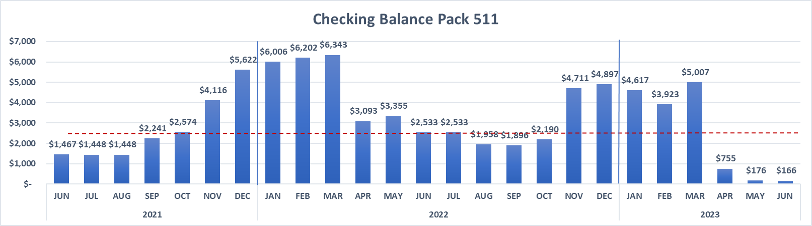

**NOTES:**

Pack Balance is lower than previous year due

Inflationary trends in all costs, including BSA fees, Supplies from BSA, Food and event activities.

Secondary concern is there was a lack of proper fundraising from the pack in 2022-2023 to fund all activities properly. .

Registration fees for BSA have increased by $7 over last year.

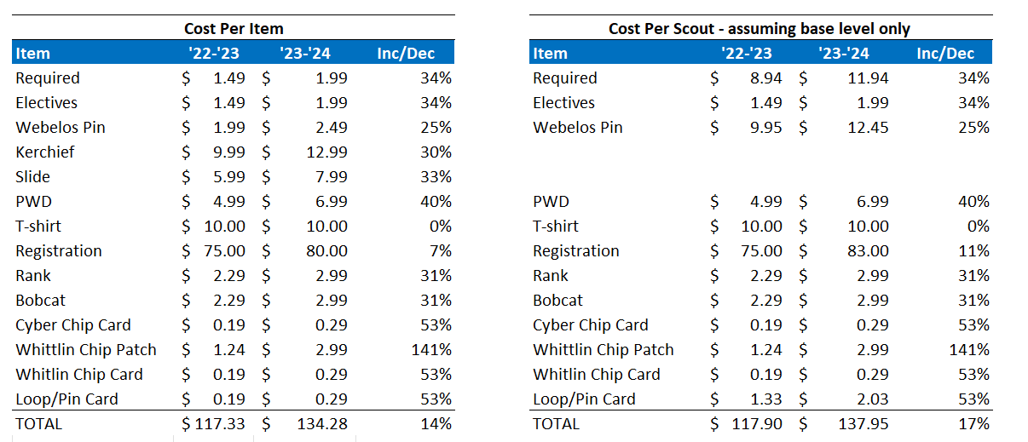

**Fund Raising [Makeda Minott & John Alford]**

We currently engage in three fund raising events:

1. Annual popcorn sales that occur in August through October,
2. Christmas Tree Collection in early January?
3. Camp Cards that occur in the spring.
4. Other opportunities?

Developing a leadership model for managing Popcorn sales and other fundraisers with a committee composed of a Fundraising Chair and representatives from each Den can be effective in parent/Scout engagement of fundraising activities.

A brief description of each role follows:

* **Fund Raising Chair:** “Popcorn Kernal”; Acts as Chairperson of the committee; attend district information/training events, relay information to other committee members; coordinates pickup and delivery of popcorn to committee members; coordinates with Pack Treasurer on delivery of proceeds to the district, coordinate distribution of camp cards and collection of proceeds with Committee Members .
* **Fundraising Committee Members**: “Popcorn Captains”; Responsible for communication of information related to fund raising to Den at Den Meetings; coordinates with Fundraising Chair to pick up popcorn and distributed to scouts at Den meetings; coordinate distribution and collection of camp cards/proceeds.

**Pack Leaders should identify these members by August Leaders Meeting, 2022**, notifying the Fundraising Chair and Pack Committee.

2020-2021 Committee

| **Role** | **Individual** |
| --- | --- |
| Fund Raising Chair (Popcorn Kernal) | Makeda Minott |
| Fund Raising Chair - in-training | John Alford |
| Tiger Representative (Popcorn Captain) |  |
| Wolf Representative (Popcorn Captain) | Krystal Shearon |
| Bear Representative (Popcorn Captain) | Mike Benken |
| WEB 1 Representative (Popcorn Captain) | John Alford |
| WEB 2 Representative (Popcorn Captain) | Cedric James |

**NOTES:**

**Starts Stops and Continues**

* **All Sales can now be conducted through Trails End APP – Including Storefront sales**

**BOOTH SALES SCHEDULE** – Should be set by August of current year – with opportunity for incoming Tigers to participate.

| **Date** | **Location** | **Time** | **Leader on Duty** |  | |
| --- | --- | --- | --- | --- | --- |
|  |  |  |  |  | |
|  |  |  |  |  | |
|  |  |  |  |  | |
|  |  |  |  |  | |

**Popcorn Fundraiser – Budgetary Items**

**Activities that require funding**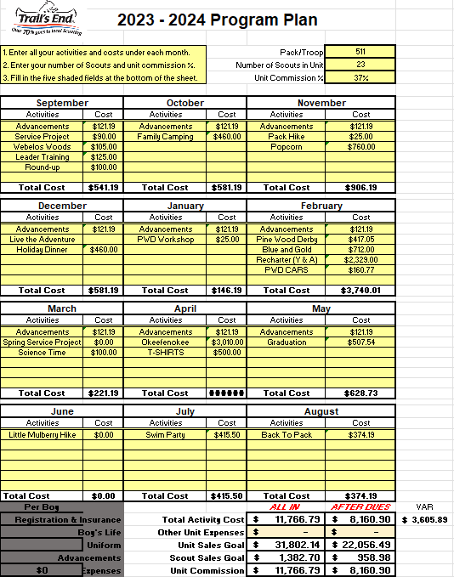

*Most activities are based on past year expenses, plus current research into upcoming charges for recharter, Okefenokee trip. .*

*Based on the Level of need (increased costs, no cushion in Bank account, gap in fundraising) the treasurer recommends the following.*

* *Basic Dues raised to $175 per scout. This will cover increased cost to operate basic pack functions and provide cushion against future increases.*
* *Total Costs to participate in the pack is $500 a year.*
* *Upfront costs owed to pack in Sept is $250 per scout* 
  + *Due by September Pack meeting.*
  + *Covers cost to fund the Pack during fundraising season and for fall activities.*
  + *$175 Pack dues are embedded within this cost*
* *Additional $250 is owed in January to fund the rest of the year.* 
  + *Unless the family participates in fundraising and meets their fundraising goal.*
  + *If the family meets their fundraising goal, then they do not owe the remaining $250.*

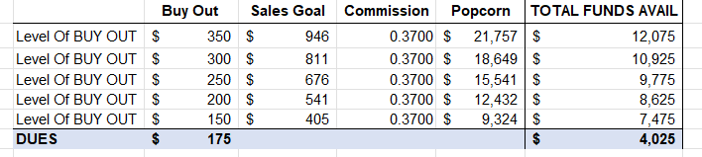

**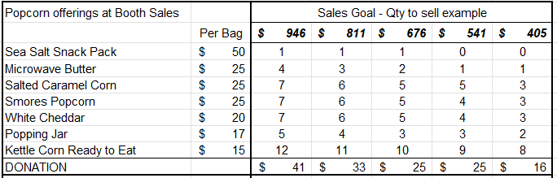

*Budget will be based on final approved activities. Sales goals will be based on the budget. Goal is 880 per scout*

**RECRUITMENT**

**New Scouts and Leaders.**

**Mission Statement**

The mission of the Boy Scouts of America is to prepare young people to make ethical and moral choices over their lifetimes by instilling in them the values of the Scout Oath and Law.

**Vision Statement**

The Boy Scouts of America will prepare every eligible youth in America to become a responsible, participating citizen and leader who is guided by the Scout Oath and Law.

**Recruitment Activities planned**

**Open House**

* 7.29.22 – Rock Springs Elementary – 8 AM - 12 PM

**Back to Pack**

* 8.20 .22– Rock Springs UMC – 3 PM- 6 PM
* Invitations sent to current Scouts will inform parents to INVITE A FRIEND - utilize QR codes

**ROUND- UP**

* 8. – Rock Springs Elementary
* Purpose of Round up to gain Den Leaders.

**PARENT ORIENTATION NIGHTS (Krystal Shearon)**

* Schedule information nights with HOA’s
  + Edgewater
  + Brook Forest
  + Others?
* Separate night for Orientation into the Pack for Parents after Round-up
  + Would this be helpful?
  + Who would like to share their “New Parent” story?
  + What Materials do the New Parents need most.

**NOTES:**

**COMMUNICATIONS**

**Tools for Outreach and Contact**

* Scoutbook – Official BSA system of Record
  + Comes with App – not useful for chats or communications
  + Desktop application more useful.
* GroupMe
  + Used for instant message Groups
  + Is this being used?
* Google Classroom

**Parent information Packets.**

Content List

**NOTES:**

**APPENDIX**

**Appendix A – Big Event / Trip Rotation**

These trips are not hard and fast, but rather a rotation of larger trips that can be done, or have been done before. Deviation to try out new adventures is always fun. Trips should always be evaluated for Success.

Trip 1: Patriots Point (2018 trip)

Trip 2: Atlanta or Chattanooga Aquarium Overnight

Trip 3: Cumberland Caverns

Trip 4: Tellus Museum (2018 Fall, 2022 Fall)

Trip 5: Warner Robins Air Force Museum (2019 Spring)

Trip 6: Okefenokee Swamp (2019 Spring)

Trip 7: Space Camp

Trip 8: Racoon MT (Caving 2020 - CANCELED)

Trip 9: Rock City, Chattanooga (2021 Spring)

**Appendix B – Pack Committee Roles as Defined by myscouting.org**

<http://www.scouting.org/scoutsource/CubScouts/Leaders/About/ThePack/pcomm.aspx>

**Appendix C – Pack Organization Chart**

Source: <http://www.scouting.org/scoutsource/CubScouts/Leaders/About/ThePack.aspx>

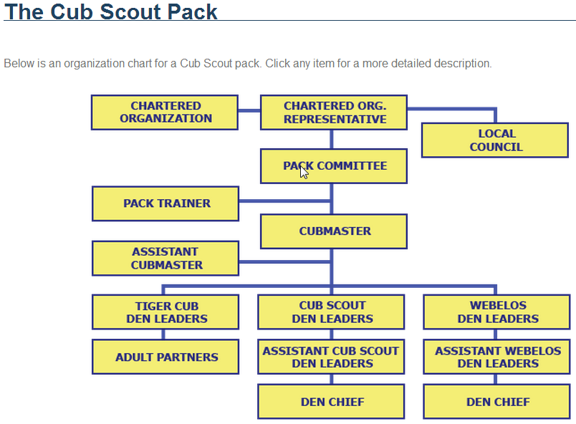

**Appendix D – Journey To Excellence**

"Scouting's Journey to Excellence" is the BSA's council performance recognition program designed to encourage and reward success and measure the performance of our units, districts, and councils. It is meant to encourage excellence in providing a quality program at all levels of the BSA. <https://www.scouting.org/wp-content/uploads/2021/05/2021-JTE-Pack-Scorecard-7-31-20.pdf>

**Appendix E – Family Scouting FAQ**

[**https://www.scouting.org/wp-content/uploads/2019/02/UPDATED-Family-Scouting-FAQ-2-11-191.pdf**](https://www.scouting.org/wp-content/uploads/2019/02/UPDATED-Family-Scouting-FAQ-2-11-191.pdf)

**Appendix F– Pack Meeting Plan Ideas**

[**https://www.scouting.org/programs/cub-scouts/pack-meeting-resources/pack-meeting-plans/**](https://www.scouting.org/programs/cub-scouts/pack-meeting-resources/pack-meeting-plans/)

**Appendix G – Gwinnett Co Public Schools**

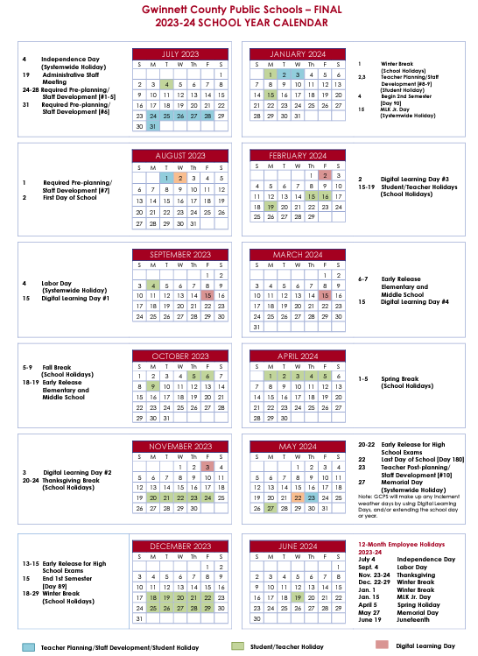

**Appendix H – Hike Club**

**Hike Club**

The Hike Club is s program to encourage more outdoor adventures with the Scouts.

**Premise** – Keeping the Outing in Scouting and Explore the Outdoors.

**Parameters** -The Hike Club is to be run under the conditions set forth in the National Outdoor Awards program offered by the BSA. See Section on the NOA on requirements on-line. The Hike Club is meant to allow Cub Scouts to start fulfilling those requirements prior to entering Scouts BSA (Formerly *Boy Scouts*)

<https://www.scouting.org/programs/scouts-bsa/advancement-and-awards/noa/>

**Rules:**

1. All hikes must be made in accordance to Youth Protection Training standards and any guidelines found in the Guide to Safe Scouting.
2. Hike are to be hosted in a manner consistent with the National Outdoor Awards program (i.e. Hike Club activity or BSA Activity)
3. Hike Club hikes should maintain a 2-factor dynamic;
   1. Physical Fitness of the hike
   2. Historical relevance or Natural wonder
4. Must be a registered Scout to participate
5. One-time $25 registration fee, non-refundable. Covers material costs. Registration costs are per Scout.

**Hike Activities:**

* 5 hikes scheduled per year at various levels of difficulty. Each year will have no less than 10 miles available per year where the hike can be completed at the Tiger level.

**Recognition:** Scouts receive recognition as miles accumulate.

* First Award @ 10 Miles – Hiking Staff with stamped grip and Scouting medallion at the top
* Second Award @ 25 Miles – Medallion (awarded according to rank)
* Third Award @ 50 Miles – 50 Miler Patch and Medallion (awarded according to rank)
* Each additional award is made every 25 miles achieved (awarded according to rank)
* Beaded cord on staff will be added on at 10 Miles – each bead will indicate a mile hiked.

**Benefits:**

* Outdoors orientation for scouts
* Helps ready Cub Scouts for Scouts BSA
* Makes Scouts comfortable in outdoor situations
* Hiking Staff, beads, and medallions are positive reinforcement
* Miles transfer to Scouts BSA
* Reinforce the Buddy System
* Numerous opportunities to draw in Scouting requirements with lessons.



| Month | Date | Location | Age Level | Est. Mileage |
| --- | --- | --- | --- | --- |
| June |  | *Little Mulberry Park* | All | 2.2 Miles |
| October |  | Amicalola Falls | Wolves up | 2.1 Miles |
| November |  | Sawnee Mountain | All | 4.0 Miles |
| December |  | Yonah Preserve | ALL | 4.0 Miles |
| February |  | Suwanee Greenway | All | 4.0 Miles |
| April |  | Blood Mountain | Webelos up | 4.3 Miles |
| June |  | Little Mulberry | ALL | 2.2 Miles |
| TOTAL HIKES |  |  |  | 24.3 Miles |

**Appendix I – Monthly Planning Guide**

**August Back to Pack Plan**

**Pack Meeting - Back to Pack THEME:**

**DATE: 8.20.22 (Saturday) –**

**TIME: 5 PM – 7 PM**

**LOCATION: Rock Springs UMC – Downstairs Fellowship Hall – Outdoor Area**

**BEFORE THE MEETING**

**GATHERING**

**OPENING:**

* Cubmaster Lead

**DEN DEMONSTRATIONS/ACTIVITIES**

* Activity 1 – Rocket Creation and Launch
  + John & Claire
* Activity 2 – Games
  + Golf ball toss
  + Cornhole
* Parents Presentation
  + Announcements of Program Year, Fundraising goals, COVID Policy.
  + How to Differentiate this from the parent orientation (perhaps maybe a Q & A)
  + have applications available

**RECOGNITION**

* NA

**CUBMASTER’s MINUTE**

**CLOSING**

**POST MEETING WRAP UP**

**September Pack Meeting – New Scouts**

**Pack Meeting – New Scouts THEME:**

**DATE: 9.28.23 (Thursday) –**

**TIME: 7 PM**

**LOCATION: Rock Springs UMC – Upstairs Fellowship Hall**

**BEFORE THE MEETING**

* **6:30 Pm latest Set up start time**

**GATHERING**

[**Manners Charades**](https://cubscoutideas.com/904/cub-scouts-good-manners-belt-loop/)

**OPENING:**

*Flag Ceremony - AOL Lead, Pledge, Oath, and Law*

**DEN DEMONSTRATIONS/ACTIVITIES - 10 Minutes per station**

**Place into Even groups - trying to bucket by age**

*Station 1: Outdoor Code 4Cs - Puzzle (write in, draw a picture, put together)*

* *Be clean in my outdoor manners.*
* *Be careful with fire.*
* *Be considerate in the outdoors.*
* *Be conservation minded.*

*Station 2: Hiking Safety, Buddy System*

*buddy check - gather in a circle (buddies in the circle) spin and find your buddy*

*recite the scout law with your buddy*

*mini skit with your buddy?*

*what to do if you get separated- STOP ( Stay Calm, Think, Observe, Plan) A Scout is Brave*

*Station 3: 6 essentials, appropriate clothing*

*bring items to show the scouts - what do you think is essential, why? (bring things that are not necessary like a nintendo switch or slinky) g*

**RECOGNITION**

summer belt loops

**CUBMASTER’s MINUTE**

**ANNOUNCEMENTS**

POPCORN!

Webelos Woods

Fall Family Camping

**CLOSING**

**POST MEETING WRAP UP**

**October Pack Meeting – Camping**

**Pack Meeting – Camping THEME:**

**DATE: 10.26.23 (Thursday) –**

**TIME: 7 PM**

**LOCATION: Rock Springs UMC – Upstairs Fellowship Hall**

**BEFORE THE MEETING**

**FALL CARNIVAL PREP**

**GATHERING**

**OPENING:**

**DEN DEMONSTRATIONS/ACTIVITIES**

* Activity 1
* Activity 2
* Activity 3

**RECOGNITION**

**CUBMASTER’s MINUTE**

**ANNOUNCEMENTS**

**CLOSING**

**November Pack Meeting**

**Pack Meeting – Trustworthy THEME: Citizenship/Community Service**

**DATE: 11.16.23 (Thursday) –**

**TIME: 7 PM**

**LOCATION: Rock Springs UMC – Upstairs Fellowship Hall**

**BEFORE THE MEETING**

* **sign for Scott? (Claire)**

**GATHERING**

* **The Big Turkey Hunt Divide the audience into seven groups. Assign a part to each group and have them practice: Pilgrim: Whistling Turkey: “Gobble, gobble!” Fish: “Bubble, bubble!” Bear: “Growl, growl!” Squirrel: “Chatter, chatter!” Bee: “Buzz, buzz!” Duck: “Quack, quack!” Hunt: All sounds at once**
* The narrator the reads the story, and groups respond to the appropriate words. Once upon a time, there was a PILGRIM who decided to go out and HUNT for a TURKEY. As he walked through the forest, he met a DUCK. The PILGRIM asked the DUCK, “Have you seen the TURKEY? I’m on a big HUNT for him.” “No,” the DUCK said, with a sly wink. So the PILGRIM marched along until he spied a SQUIRREL playing in the treetops. “Good day, SQUIRREL,” the PILGRIM said. “Have you seen the TURKEY? I’m on a big HUNT for him.” “No, no,” the SQUIRREL said, smiling behind his paw. As the PILGRIM crossed the brook, he bent toward the water and saw a FISH swimming near the surface. “Oh, FISH,” said he, “has the TURKEY been down to the water for a drink today?” “No, not for a long time,” the FISH said, diving deep to hide his laughter. The poor PILGRIM continued down the shady path and suddenly came face to face with a big, brown BEAR. “Hello, B-B-BEAR,” said the PILGRIM. “H-h-have you s-s-seen the TURKEY? I’m on a big HUNT for him.” “No,” the BEAR said. “I don’t even know what a TURKEY is.” But he gave a rumbling laugh. The PILGRIM was feeling quite depressed by now, for he thought that he would never find the TURKEY. Finally, he saw a BEE buzzing by. “Stop a minute, BEE,” he said. “You fly just about everywhere. Is the TURKEY near? I’m on a big HUNT for him.” “No,” buzzed the BEE, “nowhere around here.” And he flew away, buzzing hard to hide his chuckles. Soon the PILGRIM saw ahead of him a clump of bushes and small trees. As he came close, there suddenly rang out from the bushes and trees the most deafening noise you’ve ever heard! It was the most ferocious growl of the BEAR, the loudest buzz of the BEE, the biggest bubbles of the FISH, the noisiest chatter of the SQUIRREL, and the deepest gobble of the TURKEY. Mr. TURKEY had hidden himself in the midst of the thicket, and all of his animal friends had gathered together to try to scare the PILGRIM out of his boots and away from the TURKEY. But guess what: The joke was on them. All the PILGRIM had wanted to do was invite the TURKEY to help him eat his bountiful Thanksgiving harvest as a way of showing thanks for all that the TURKEY had done to help with the harvest! As the poor, misunderstood PILGRIM let out a loud yell and took off for home, all heard him exclaim as he went out of sight, “That’s the last HUNT I’ll go on—so good night, good night!”

**OPENING: Flag Ceremony**

**DEN STATIONS:**

* Thank You Cards for Soldiers (To be sent to the unit replacing Scott's group)
* “My Hero Awards”
* Community Heros
* Create your own superhero <https://www.amazon.com/Capes-Stickers-Costumes-Halloween-Cosplay/dp/B0B8SQ8X1D/ref=sr_1_16?crid=3OELU7B3QE4MI&keywords=superhero+capes+bulk+30&qid=1698963662&sprefix=superhero+capes+bulk+30%2Caps%2C118&sr=8-16>

**RECOGNITION**

Scout for Food Patch

**CUBMASTER’s MINUTE**

**ANNOUNCEMENTS**

**CLOSING**

**POST MEETING WRAP UP**

**December Pack Meeting**

**Pack Meeting – Courteous THEME: Faith/Diversity**

**DATE: 12.15.22 (Thursday) –**

**TIME: 7 PM**

**LOCATION: Rock Springs UMC – Upstairs Fellowship Hall**

**BEFORE THE MEETING**

* **Check-in Questions**

**GATHERING**

**OPENING: Wolves/Tigers?**

**DEN DEMONSTRATIONS/ACTIVITIES**

**RECOGNITION**

**CUBMASTER’s MINUTE**

**ANNOUNCEMENTS**

**wreaths**

**CLOSING**

**POST MEETING WRAP UP**

**January Pack Meeting**

**Pack Meeting – Helpful THEME: Emergency Prep/First Aid**

**DATE: 1.26.23 (Thursday) –**

**TIME: 7 PM**

**LOCATION: Rock Springs UMC – Upstairs Fellowship Hall**

**BEFORE THE MEETING**

* **Check-in Questions**

**GATHERING**

**OPENING: Tigers w/Wolf support (Skit & Colors)**

**DEN DEMONSTRATIONS/ACTIVITIES**

**RECOGNITION**

**CUBMASTER’s MINUTE**

**ANNOUNCEMENTS**

**February Pack Meeting**

**Pack Meeting – Helpful THEME: Skits & Stories**

**DATE: 2/23/23 (Thursday) –**

**TIME: 7 PM**

**LOCATION: Rock Springs UMC – Upstairs Fellowship Hall**

**BEFORE THE MEETING**

* **Check-in Questions**

**GATHERING**

**OPENING: Bears**

**DEN DEMONSTRATIONS/ACTIVITIES**

* PWD

**RECOGNITION**

**CUBMASTER’s MINUTE**

**ANNOUNCEMENTS**

**CLOSING**

**POST MEETING WRAP UP**

**March Pack Meeting**

**Pack Meeting – Obedience THEME: Hiking**

**DATE: 3/23/23 (Thursday) –**

**TIME: 7 PM**

**LOCATION: Rock Springs UMC – Upstairs Fellowship Hall**

**BEFORE THE MEETING**

* **Check-in Questions**

**GATHERING**

**OPENING:**

**Leave No Trace**

**DEN ACTIVITIES :**

1. [**Flower Scavenger Hunt**](https://docs.google.com/document/d/1aiz2_ypQ3J0iAMpekIiLDpIUmyLq9f9JDoCwc6GsBHc/edit?usp=sharing) **(NEED COPIES PRINTED)**

**Print 1 copy of each flower and place around the room or taped to chairs.**

**Each Scout gets a copy of the 3x3 grid. Scouts will walk around, draw/color the flowers, and write the name of each flower. These are all native plants to Georgia.**

1. **Water Conservation** [**Word Search**](https://www.sciencekids.co.nz/quizzes/wordsearch/waterprintable.html) **(NEED COPIES)**
2. [**Water Conservation Wall**](https://docs.google.com/document/d/14-bZoFCTV-bEhULkMxCGnvRyRQINBks6uM4uPUbR0u0/edit?usp=sharing) **(NEED BUTCHER PAPER, GLUE STICKS)**

**Print 1 copy and cut into strips, have students pick 2 or 3 to glue to the wall and draw what that looks like**

**RECOGNITION**

**CUBMASTER’s MINUTE**

**ANNOUNCEMENTS**

**CLOSING**

**POST MEETING WRAP UP**

**April Pack Meeting**

**Pack Meeting – Obedience THEME: Hiking**

**DATE: 3/23/23 (Thursday) –**

**TIME: 7 PM**

**LOCATION: Rock Springs UMC – Upstairs Fellowship Hall**

**BEFORE THE MEETING**

* **Check-in Questions**

**GATHERING**

**OPENING:**

**DEN DEMONSTRATIONS/ACTIVITIES**

**RECOGNITION**

**CUBMASTER’s MINUTE**

**ANNOUNCEMENTS**

**CLOSING**

**POST MEETING WRAP UP**

**Appendix J – NEGA COVID-19 Guidelines**

Updated May 30, 2021

On May 28, 2021, Governor Kemp issued Executive Order 05.28.21.02 effective May 31, 2021 and continuing until June 15, 2021 (“Order”).   As discussed below, the Order allows Scouting to return to normal operations.

**GENERAL OBSERVATIONS**.

* Under the new Order, the restrictions on gatherings, wearing of masks, social distancing, etc. have been eliminated in Georgia for events such as scouting.  For example, masks are not required at meetings, outdoor events, campouts, etc.  There are no group size restrictions that apply to meetings, campouts, etc.  Social distancing is no longer required in scouting events.
* Governor Kemp noted the restrictions were removed from events such as scouting because of declining hospitalizations, declining percentage of positive tests and declining deaths due to the increasing availability of vaccinations and public awareness of COVID-19 mitigation measures.
* As practical and to maintain this positive direction, please continue following practices that promote good health.  For example, frequent washing of hands and Covid screening questionnaires remain desirable, as practical.
* Of importance, we recognize that individuals are not the same.  Parents of scout participants and adult volunteers may voluntarily wear masks or take other preventative measures.  We respect and support an individual’s desires to take such actions.
* Please be aware that chartered organizations may still impose more restrictive guidelines.   For example, if a chartered organization mandates wearing masks while meeting at the chartered organization’s facility, the unit must honor such restrictions while meeting in the facility.
* Please be aware that as your unit travels out of state, different health care guidelines may apply.

**AN IMPORTANT REMINDER**

While health care indicators are improving, be aware that we live in a world where potential for COVID-19 exposure remains.  Please use common sense.

**CLOSING COMMENTS**

We are delighted that scout meetings and events can return to a more normal state.  Be aware that health care guidelines applicable to our summer camps will be shared with units attending the camps.  Such guidelines continue to evolve.  Please also remember that scouts are good citizens in our communities.  Businesses and organizations in our communities may have different restrictions – and we honor such restrictions.   Finally, be aware the Order continues to impose some restrictions in non-scouting areas – such as long-term care facilities.

Please enjoy your summer scouting events and experiences.  Be safe.  Be kind.

Northeast Georgia Council, Key Three

Craig Pett, Council President

Carter Wood, Council Commissioner

Trip Selman, Scout Executive

**Appendix K – Retiring Adventures**



May 11, 2021

Every year, Cub Scout Adventures are reviewed to identify trends and determine interests of our youth, den leaders and Cub Scout families. In our ongoing efforts to keep the Cub Scouting Adventure program relevant to today’s families, Cub Scout elective Adventures are reviewed for both content and popularity.

The most recent review has identified 19 elective Adventures that do not meet the standards of youth and den leader engagement, with the lowermost being earned by less than 3% of eligible youth. They will be retired effective **May 31, 2022**.

The retiring of these adventures allows Cub Scouting to be more agile as the BSA makes continuous improvements to the program.

Some families may want one last chance to earn these Adventures, and some den leaders may have already made plans for the upcoming program year.

To help with that transition, **these Adventures will be available until the end of the 2021-2022 program year**.

The affected elective Adventures, which will be retired effective May 31, 2022, are as follows:



* Family Stories, Rank: Tiger, SKU: 619922
* Earning Your Stripes, Rank: Tiger, SKU: 619925
* Tiger Theater, Rank: Tiger, SKU: 619931
* Tiger Tales, Rank: Tiger, SKU: 619930
* Collections and Hobbies, Rank: Wolf, SKU: 619940
* Grow Something, Rank: Wolf, SKU: 619944
* Hometown Heroes, Rank: Wolf, SKU: 619947
* Motor Away, Rank: Wolf, SKU: 619950

The listed elective Adventures are still part of the Cub Scouting program until May 31, 2022. After that date, these Adventures will be retired, and the Adventure loops and pins will no longer be available. Earned Adventures will be archived in Scoutbook and Internet Advancement. The Adventure will appear as earned but will no longer be able to be marked as completed after **May 31, 2022**.